A Moment in Time

St. Francis Orphanage and Mount Alvernia High School ~ 1926

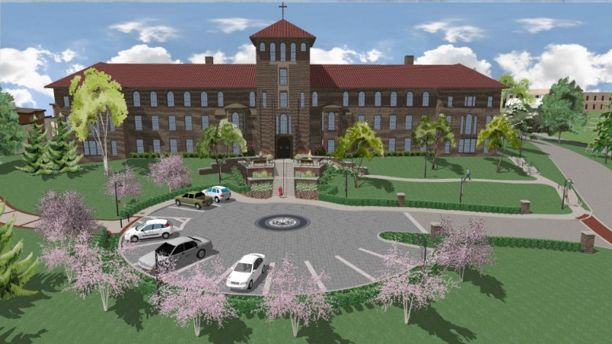

Presently Francis Hall in Alvernia University

Today, Francis Hall in Alvernia University, formerly St. Francis Orphanage and Mount Alvernia High School, is unique in its ideals in its founding in the Franciscan Spirit as the purpose of its existence changed from serving orphans to fostering religious vocations, to educating men and women in a collegiate setting. During the passing years, it has been adapted to the needs of the mission of the congregation.

The decision to build St. Francis Orphanage, which was made during the term of Mother Hedwig Leszczynska, Superior General of the Congregation (1912 – 1930) grew from the acceptance of orphans during the early years of our community here in Reading when Mother Veronica welcomed a nine-year-old orphan girl, Mary, at St. Mary’s Convent in the city.

When Mother Veronica and the sisters moved into the newly built Motherhouse, Sacred Heart Convent, from Ridgewood, the orphans accompanied them. The convent was built with specific accommodations for the orphans. As the number of orphans increased and the number of young women who began preparation for religious life also increased the congregation was faced with the necessity of building a structure to house them. In 1924 construction of the building began and in 1926 the children moved from the convent to the new building, which became known as St. Francis Orphanage. The young women, aspiring to be sisters, also moved from the convent to the new building under the name of Mount Alvernia High School. As administrator of this building project, Mother Hedwig provided services necessary for resident orphans, including their education as well as residential and educational facilities for the young women planning to enter the congregation. Mother Hedwig envisioned not only the functional aspects of the building but also a structure aesthetically pleasing and attractive to provide inspiration for all those being sheltered.
Source: “Designed to Serve” by Sister M. Pacelli, OSF pp. 7-9

